***#Assignment A5-SQL#***

**Problem Statement:** PL/SQL Stored Procedure and Stored Function.

Write a Stored Procedure namely proc_Grade for the categorization of student. If marks scored by students in examination is <=1500 and marks>=990 then student will be placed in distinction category if marks scored are between 989 and900 category is first class, if marks 899 and 825 category is Higher Second Class.  
**Source Code:**

-- Create Stud_Mark_s table

SELECT * FROM STUD_MARK_S;

DROP TABLE Stud_Mark_s;

CREATE TABLE Stud_Mark_s (

Roll_No NUMBER PRIMARY KEY,

Name VARCHAR2(100),

Total_Marks NUMBER

);

-- Insert sample data into Stud_Mark_s table with Roll Numbers

INSERT INTO Stud_Mark_s (Roll_No, Name, Total_Marks) VALUES (1, 'Aarav Sharma', 1200);

INSERT INTO Stud_Mark_s (Roll_No, Name, Total_Marks) VALUES (2, 'Vivaan Patel', 980);

INSERT INTO Stud_Mark_s (Roll_No, Name, Total_Marks) VALUES (3, 'Aditya Mehta', 1500);

INSERT INTO Stud_Mark_s (Roll_No, Name, Total_Marks) VALUES (4, 'Vihaan Rao', 850);

INSERT INTO Stud_Mark_s (Roll_No, Name, Total_Marks) VALUES (5, 'Arjun Singh', 700);

INSERT INTO Stud_Mark_s (Roll_No, Name, Total_Marks) VALUES (6, 'Krishna Kumar', 1120);

INSERT INTO Stud_Mark_s (Roll_No, Name, Total_Marks) VALUES (7, 'Sai Joshi', 920);

INSERT INTO Stud_Mark_s (Roll_No, Name, Total_Marks) VALUES (8, 'Anaya Gupta', 1350);

INSERT INTO Stud_Mark_s (Roll_No, Name, Total_Marks) VALUES (9, 'Saanvi Verma', 800);

INSERT INTO Stud_Mark_s (Roll_No, Name, Total_Marks) VALUES (10, 'Aanya Nair', 1050);

INSERT INTO Stud_Mark_s (Roll_No, Name, Total_Marks) VALUES (11, 'Rohan Chatterjee', 900);

INSERT INTO Stud_Mark_s (Roll_No, Name, Total_Marks) VALUES (12, 'Pooja Desai', 950);

INSERT INTO Stud_Mark_s (Roll_No, Name, Total_Marks) VALUES (13, 'Kavya Bhatia', 980);

INSERT INTO Stud_Mark_s (Roll_No, Name, Total_Marks) VALUES (14, 'Shivam Yadav', 700);

INSERT INTO Stud_Mark_s (Roll_No, Name, Total_Marks) VALUES (15, 'Tanvi Sethi', 1100);

INSERT INTO Stud_Mark_s (Roll_No, Name, Total_Marks) VALUES (16, 'Niranjan Reddy', 1150);

INSERT INTO Stud_Mark_s (Roll_No, Name, Total_Marks) VALUES (17, 'Harshitha Rani', 780);

INSERT INTO Stud_Mark_s (Roll_No, Name, Total_Marks) VALUES (18, 'Rajesh Malhotra', 1300);

INSERT INTO Stud_Mark_s (Roll_No, Name, Total_Marks) VALUES (19, 'Sneha Iyer', 880);

INSERT INTO Stud_Mark_s (Roll_No, Name, Total_Marks) VALUES (20, 'Aarushi Khanna', 950);

SELECT * FROM RESULT_S;

-- Create Result_s table with Roll_No field

CREATE TABLE Result_s (

Roll_No NUMBER PRIMARY KEY,

Name VARCHAR2(100),

Class VARCHAR2(50)

);

CREATE OR REPLACE PROCEDURE proc_Grade_S (

p_roll IN NUMBER,

p_name IN VARCHAR2,

p_total_marks IN NUMBER

) AS

v_class VARCHAR2(50);

BEGIN

IF p_total_marks >= 990 AND p_total_marks <= 1500 THEN

v_class := 'Distinction';

ELSIF p_total_marks >= 900 AND p_total_marks < 990 THEN

v_class := 'First Class';

ELSIF p_total_marks >= 825 AND p_total_marks < 900 THEN

v_class := 'Higher Second Class';

ELSE

v_class := 'FAIL';

END IF;

INSERT INTO Result_s (Roll_No, Name, Class)

VALUES (p_roll, p_name, v_class);

COMMIT;

EXCEPTION

WHEN OTHERS THEN

DBMS_OUTPUT.PUT_LINE('An error occurred: ' || SQLERRM);

END;

/

DROP PROCEDURE PROC_GRADE_S;

DECLARE

v_total_marks NUMBER;

v_roll NUMBER;

v_name VARCHAR2(100); -- Variable to store the student's name

BEGIN

DBMS_OUTPUT.PUT_LINE('Enter Roll Number:');

v_roll := &roll_number; -- Accepts the roll number from user input

BEGIN

SELECT Total_Marks, Name INTO v_total_marks, v_name

FROM Stud_Mark_s

WHERE Roll_No = v_roll;

EXCEPTION

WHEN NO_DATA_FOUND THEN

DBMS_OUTPUT.PUT_LINE('No student found with Roll No: ' || v_roll);

RETURN;

END;

proc_Grade_s(v_roll, v_name, v_total_marks);

DECLARE

v_class VARCHAR2(50);

BEGIN

SELECT Class INTO v_class

FROM Result_s

WHERE Roll_No = v_roll;

DBMS_OUTPUT.PUT_LINE('Roll No: ' || v_roll || ', Name: ' || v_name || ', Class: ' || v_class);

EXCEPTION

WHEN NO_DATA_FOUND THEN

DBMS_OUTPUT.PUT_LINE('No result found for Roll No: ' || v_roll);

END;

EXCEPTION

WHEN OTHERS THEN

DBMS_OUTPUT.PUT_LINE('An error occurred: ' || SQLERRM);

END;

/

**Output:**

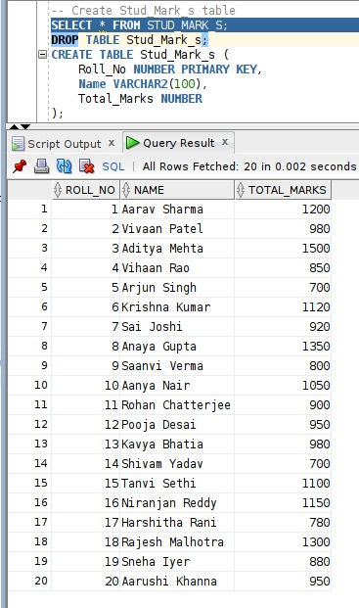

Marks Table

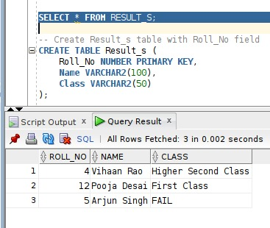

Fine Table